**DAILY ONLINE ACTIVITIES SUMMARY**

|  |  |  |  |  |  |  |  |  |
| --- | --- | --- | --- | --- | --- | --- | --- | --- |
| **Date:** | **23-05-2020** | | | | | **Name:** | **Rohan Mahaveer** | |
| **Sem & Sec** | **6th B** | | | | | **USN:** | **4AL17CS077** | |
| **Online Test Summary** | | | | | | | | |
| **Subject** | | **Python** | | | | | | |
| **Max. Marks** | | **30** | | **Score** | | | **18** | |
| **Certification Course Summary** | | | | | | | | |
| **Course** | **Ethical Hacking** | | | | | | | |
| **Certificate Provider** | | | **Alison** | | **Duration** | | | **6hrs** |
| **Coding Challenges** | | | | | | | | |
| Problem Statement: 1. Write a java program to implement round robin scheduling algorithm.Calculate AVG WT AND TAT. INPUT:NO OF PROCESSES,BURST TIME AND TIME QUANTUM.  2. Write a Java Program to separate the Individual Characters from a String | | | | | | | | |
| **Status:** YES, Completed all Programs | | | | | | | | |
| **Uploaded the report in Github** | | | | | **YES** | | | |
| **If yes Repository name** | | | | | <https://github.com/rohanmahaveer/daily-status> | | | |
| **Uploaded the report in slack** | | | | | **YES** | | | |

Online Test Details:

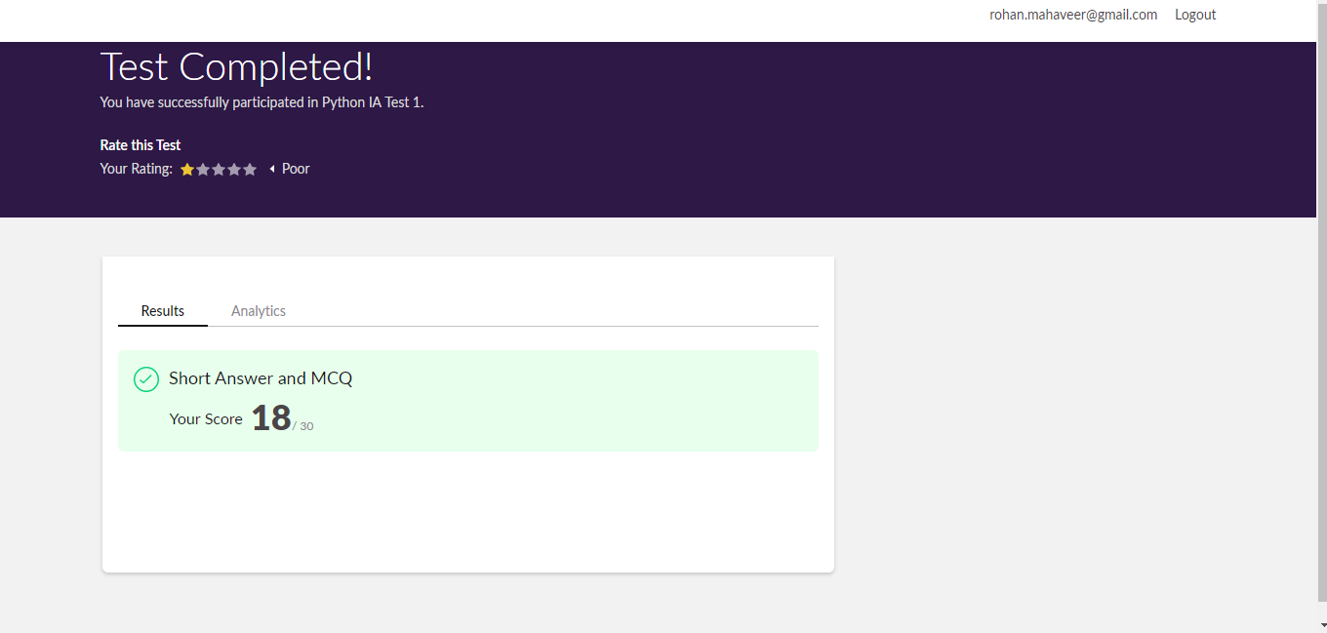

Scored 18 out of 30 in Python 1st I.A test

Certification Course Details:

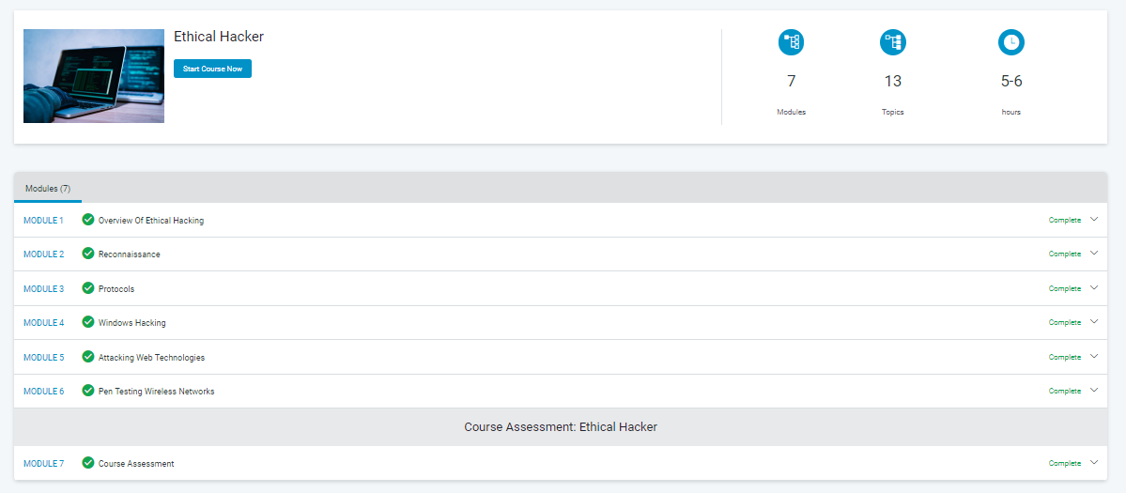

The above course is being taken up by me is based on Ethical hacking. Today in online course I studied about wireless hacking, malware, cryptography .In the End took the course assessment and completed course. The details of the course and certificate provider are mentioned in the above form.

Coding Challenges Details:

Program1:

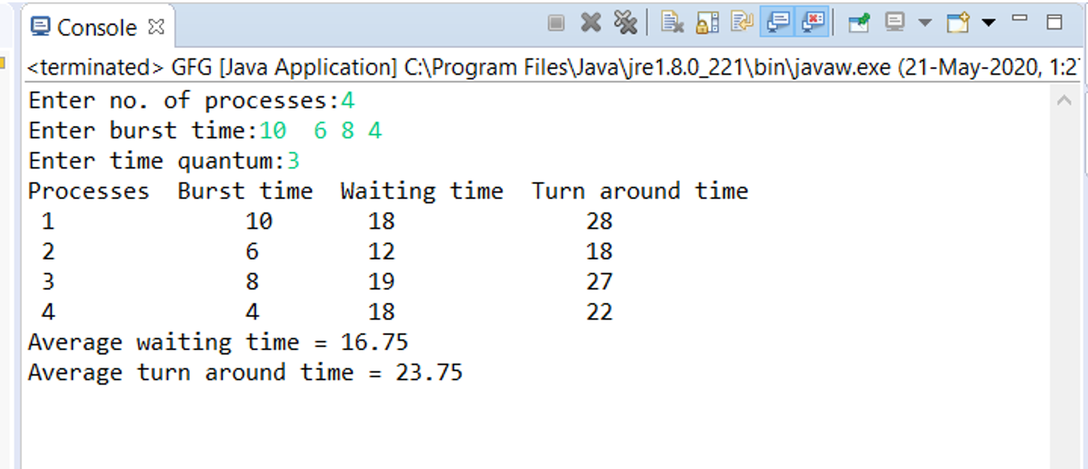

Program2:

